**Access two dimensional array using pointers**

How to access two dimensional array using pointers in C programming? Write a C program to input and print elements of a two dimensional array using pointers and functions.

**Example**

**Input**

Input elements in 3x3 matrix:

1 2 3

4 5 6

7 8 9

**Output**

Elements of 3x3 matrix:

1 2 3

4 5 6

7 8 9

**How to access two dimensional array using pointers?**

To access a two dimensional array using pointer, let us recall basics from [one dimensional array](https://codeforwin.org/2017/11/c-program-input-print-array-elements-using-pointers.html). Since it is just an array of one dimensional array.

Suppose I have a pointer array_ptr pointing at base address of one dimensional array. To access nth element of array using pointer we use *(array_ptr + n) (where array_ptr points to 0th element of array, n is the nth element to access and nth element starts from 0).

Now we know two dimensional array is array of one dimensional array. Hence let us see how to access a two dimensional array through pointer.

Let us suppose a two-dimensional array

int matrix[3][3];

For the above array,

matrix => Points to base address of two-dimensional array.

Since array decays to pointer.

*(matrix) => Points to first row of two-dimensional array.

*(matrix + 0) => Points to first row of two-dimensional array.

*(matrix + 1) => Points to second row of two-dimensional array.

**matrix => Points to matrix[0][0]

*(*(matrix + 0)) => Points to matrix[0][0]

*(*(matrix + 0) + 0) => Points to matrix[0][0]

*(*matrix + 1) => Points to matrix[0][1]

*(*(matrix + 0) + 1) => Points to matrix[0][1]

*(*(matrix + 2) + 2) => Points to matrix[2][2]

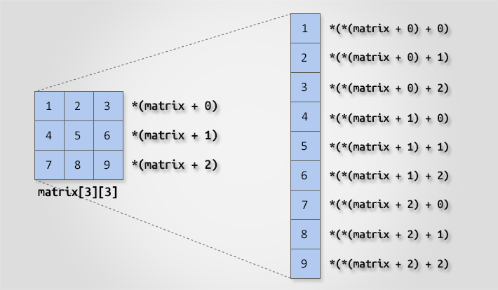Two dimensional array access using pointer

**Program to access a two dimensional array using pointer**

/**

* C program to access two dimensional array using pointer.

*/

#include <stdio.h>

#define ROWS 3

#define COLS 3

/* Function declaration to input and print two dimensional array */

void inputMatrix(int matrix[][COLS], int rows, int cols);

void printMatrix(int matrix[][COLS], int rows, int cols);

int main()

{

int matrix[ROWS][COLS];

int i, j;

/* Input elements in matrix */

printf("Enter elements in %dx%d matrix.\n", ROWS, COLS);

inputMatrix(matrix, ROWS, COLS);

/* Print elements in matrix */

printf("Elements of %dx%d matrix.\n", ROWS, COLS);

printMatrix(matrix, ROWS, COLS);

return 0;

}

/**

* Function to take input in two dimensional array (matrix)

* from user.

*

* @matrix 2D array to store input.

* @rows Total rows in 2D matrix.

* @cols Total columns in 2D matrix.

*/

void inputMatrix(int matrix[][COLS], int rows, int cols)

{

int i, j;

for(i = 0; i < rows; i++)

{

for(j = 0; j < cols; j++)

{

// (*(matrix + i) + j is equivalent to &matrix[i][j]

scanf("%d", (*(matrix + i) + j));

}

}

}

/**

* Function to display elements of two dimensional array (matrix)

* on console.

*

* @matrix 2D array to display as output.

* @rows Total rows in 2D matrix.

* @cols Total columns in 2D matrix.

*/

void printMatrix(int (*matrix)[COLS], int rows, int cols)

{

int i, j;

for (i = 0; i < rows; i++)

{

for (j = 0; j < cols; j++)

{

// *(*(matrix + i) + j) is equivalent to matrix[i][j]

printf("%d ", *(*(matrix + i) + j));

}

printf("\n");

}

}